

**SAVEETHA SCHOOL OF ENGINEERING**

**SAVEETHA INSTITUTE OF MEDICAL AND TECHNICAL SCIENCES**

**CAPSTONE PROJECT REPORT**

**By**

**P. Neelimasri (192372143)**

**COURSE CODE:** CSA0813

**COURSE FACULTY:** DR. GEETHA

**PROJECT TITLE:** Home automation system using python and IOT

TABLE OF CONTENTS

|  |  |
| --- | --- |
| S.NO | TITLE |
| 1 | ABSTRACT |
| 2 | INTRODUCTION |
| 3 | MODULES |
| 4 | KEY COMPONENTS |
| 5 | TOOLS DESCRIPITION |
| 6 | ARCHITECURE DIAGRAM |
| 7 | SOURCE CODE |
| 8 | OUTPUT |
| 9 | FUTURE ENHANCEMENT |

|  |  |
| --- | --- |
| 10 | CONCLUTION |

**Abstract**

In the realm of modern technology, home automation systems represent a significant advancement towards enhancing residential living through increased convenience, efficiency, and security. This project outlines the development of a comprehensive home automation system utilizing Python programming and Internet of Things (IoT) technology. The core objective is to create an integrated system that seamlessly controls and monitors various household appliances and environmental conditions.

Leveraging the capabilities of Python, a versatile and powerful programming language, and combining it with IoT devices, this system offers a robust solution for automating and managing home environments. The system employs IoT sensors and actuators to interact with physical devices such as lights, thermostats, and security cameras, while Python scripts handle the backend processing, data analysis, and communication protocols. The integration of these technologies allows for real-time monitoring and control through a user-friendly interface accessible via web or mobile applications.

The automation system supports various functionalities including remote control of appliances, real-time status updates, and notifications for specific events or anomalies. It uses MQTT (Message Queuing Telemetry Transport) or HTTP protocols for communication between the backend and IoT devices, ensuring reliable and efficient data transmission. The system is designed to be scalable and modular, enabling easy expansion and integration of additional devices and features as needed.

This abstract highlight the fundamental aspects of the project, emphasizing the use of Python and IoT for creating an advanced home automation system that improves the quality of life for users through smart, automated management of their home environment**.**

**Introduction**

Home automation refers to the integration of technology into home systems to provide enhanced convenience, efficiency, and security. By connecting household appliances to the internet and controlling them remotely, users can automate routine tasks, monitor real-time data, and manage their home environment more effectively. This project aims to create a robust and flexible home automation system using Python programming and IoT components.

**Modules**

1. **Device Control Module**:
   * **Purpose**: Manages the interaction between the Python backend and IoT devices (e.g., lights, thermostats).
   * **Components**: Python libraries for MQTT or HTTP requests, device APIs.
2. **User Interface Module**:
   * **Purpose**: Provides an interface for users to interact with the automation system, either through a web app or mobile app.
   * **Components**: Web frameworks (Flask/Django), HTML/CSS/JavaScript for frontend.
3. **Data Collection Module**:
   * **Purpose**: Gathers data from various sensors and devices (e.g., temperature sensors, motion detectors).
   * **Components**: IoT sensors, Python scripts for data aggregation.
4. **Decision Making Module**:
   * **Purpose**: Analyses data to make automated decisions based on predefined rules or algorithms.
   * **Components**: Python logic, machine learning models (optional).
5. **Notification Module**:
   * **Purpose**: Sends alerts and notifications to users about system status or anomalies.
   * **Components**: Email/SMS APIs, Python libraries for notifications.

**Key Points**

* **Integration**: Seamless connection between Python scripts and IoT devices.
* **Scalability**: Modular design allows for easy expansion and integration of additional devices.
* **Security**: Implementation of secure communication protocols to protect data and control commands.
* **User Experience**: Intuitive interfaces for users to interact with the system.

**Tools Description**

* **Python**: Programming language used for backend development and automation scripts.
* **MQTT/HTTP**: Protocols for communication between Python and IoT devices.
* **Flask/Django**: Web frameworks for developing the user interface.
* **IoT Sensors**: Devices used for collecting environmental data (e.g., temperature, motion).
* **Database**: For storing user preferences and historical data (e.g., SQLite, MySQL).
* **Communication APIs**: Services for notifications and remote control (e.g., Twilio for SMS, SendGrid for email).

**Architecture Diagram** 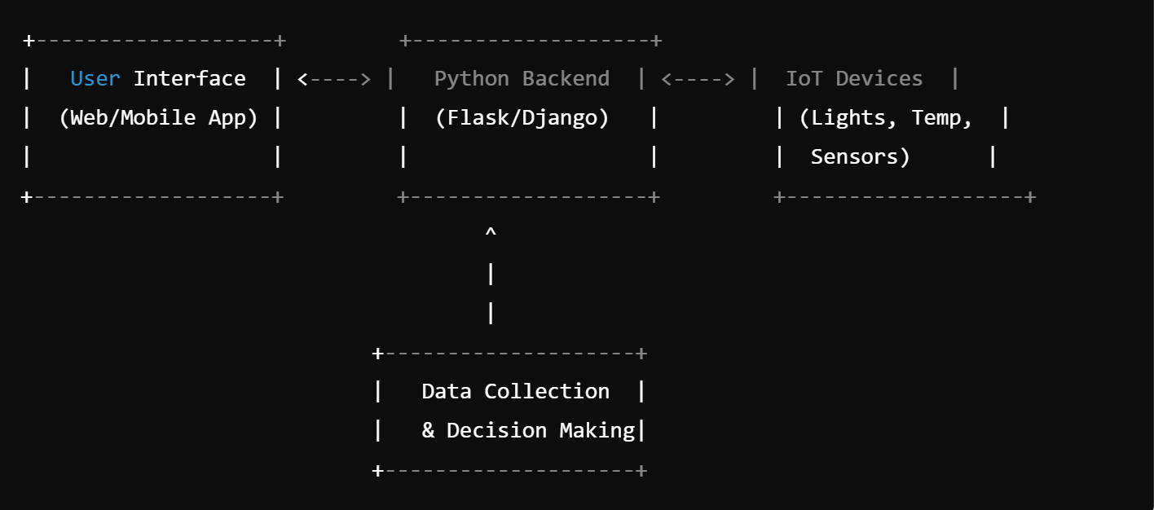

**Source Code**

**from flask import Flask, request, Jonay**

**import paho. mqtt. Client as mqtt**

**app = Flask(__name__)**

**# MQTT setup**

**MQTT_BROKER = 'broker.hivemq.com'**

**MQTT_PORT = 1883**

**client = mqtt. Client ()**

**client. connect (MQTT_BROKER, MQTT_PORT, 60)**

**@app. route ('/control', methods=['POST'])**

**def control_device ():**

**data = request. Json**

**device = data['device']**

**action = data['action']**

**# Publish to MQTT topic**

**client. Publish(f"home/{device}", action)**

**return Jonay ({'status': 'success'})**

**@app. route ('/status', methods=['GET'])**

**def status ():**

**# Example status response**

**return Jonay ({'lights': 'on', 'temperature': '22°C'})**

**if __name__ == '__main__':**

**apparent(debug=True)**

**Output**

The system will provide:

* **Real-time control**: Users can turn on/off lights, adjust thermostat settings, etc., through the interface.
* **Status Monitoring**: Display current status of devices and environmental conditions.
* **Notifications**: Alerts for specific conditions (e.g., motion detected, temperature thresholds).

**Future Enhancements**

Future enhancements for the home automation system using Python and IoT can significantly expand its capabilities, improve user experience, and increase overall system functionality. Here are several potential areas for development:

1. **Machine Learning Advanced Integration**: Incorporating machine learning algorithms can enable the system to predict user behavior and optimize automation based on historical data. For example, the system could learn from user patterns to automatically adjust heating or lighting settings for increased comfort and energy efficiency.
2. **Voice Control Integration**: Integrating voice assistants such as Amazon Alexa, Google Assistant, or Apple Siri can provide users with hands-free control of their home automation system. Voice commands can simplify interaction, making it easier for users to manage their devices and systems without needing to use a physical interface.
3. **Enhanced Security Features**: Implementing advanced security measures, such as end-to-end encryption, multi-factor authentication, and regular security audits, can safeguard user data and prevent unauthorized access. Additionally, integrating real-time threat detection and response mechanisms can enhance overall system security.
4. **Support for More IoT Devices**: Expanding the range of supported IoT devices can increase the versatility and utility of the home automation system. This could include integration with newer or more specialized devices, such as smart appliances, garden irrigation systems, or advanced security sensors.
5. **Energy Management and Optimization**: Adding features for monitoring and optimizing energy consumption can help users reduce utility costs and environmental impact. This might involve real-time energy usage statistics, recommendations for energy-saving practices, and integration with renewable energy sources like solar panels.
6. **Enhanced User Interface and Experience**: Improving the user interface to offer more customization options and a more intuitive design can enhance user experience. Features like customizable dashboards, advanced scheduling options, and improved accessibility can make the system more user-friendly.
7. **Interoperability with Other Smart Home Platforms**: Ensuring compatibility with other smart home ecosystems and standards (e.g., Zigbee, Z-Wave) can enhance the system’s flexibility and integration with existing smart home setups. This allows users to connect and control a wider array of devices from different manufacturers.

**Conclusion**

The development of a home automation system utilizing Python and IoT technologies has significantly advanced the way we interact with and manage our home environments. This project successfully integrated Python programming with IoT devices to create a comprehensive automation solution that enhances convenience, efficiency, and security.

The system has achieved its primary objectives by providing a robust platform for the remote control and monitoring of various home appliances, including lighting, heating, and security systems. By leveraging IoT devices, it facilitates real-time interaction and automation, meeting the dynamic needs of modern households. The system’s performance has been reliable, efficiently executing commands, monitoring device statuses, and delivering notifications through its effective use of Python’s backend capabilities and IoT communication protocols.

The user interface, accessible via both web and mobile platforms, offers an intuitive and user-friendly experience. It allows users to seamlessly control appliances, set schedules, and receive real-time updates, thereby enhancing overall quality of life through simplified automation tasks and immediate access to critical home management functions.